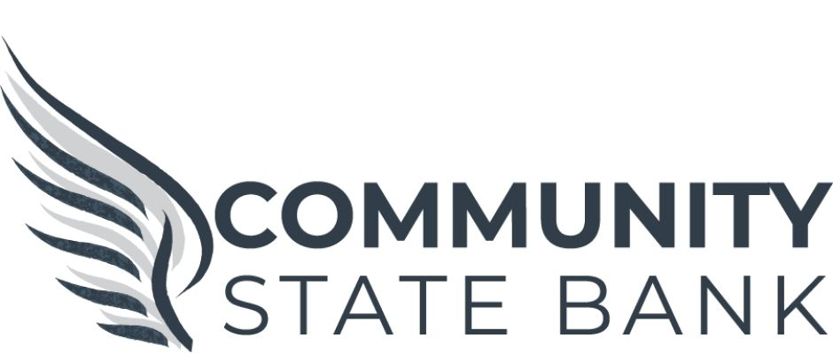

Continuing Education Scholarship Criteria

To be eligible for this scholarship, the applicant must be a student residing in a school district within our market area and have been accepted into a post secondary school.
To apply for this scholarship:
- Write an essay stating why the applicant feels they are deserving of the scholarship. The essay must be typed and a minimum of 250 words.
- Complete the Community State Bank Scholarship Application (see attached).
- The applicant must have two letters of recommendation - one from a teacher and one from another mentor. The letters should address the student and these topics as it pertains to them: Initiative, Cooperation, Leadership, Dependability, & Character.
- The applicant must present a letter of acceptance from a post-secondary school.
- All application materials must be turned in to Community State Bank by April 30, 2021. Hard copies or electronic submissions are accepted.
- All applicants will be contacted by Community State Bank to schedule an interview with the scholarship committee.

For any questions or to submit applications electronically,
please contact Morgan Rhone, Marketing Manager at Community State Bank at (814)447-5552 ext. 3239 or Morgan.Rhone@CommunityState.Bank

Continuing Education Scholarship Application

NAME ______________________________________________________

ADDRESS ___________________________________________________
PHONE#______________________ EMAIL _______________________
PARENTS NAME _____________________________________________

SCHOOL DISTRICT___________________________________________

COLLEGE ATTENDING _______________________________________

MAJOR ______________________________________________________

School Activities:

Honors & Awards: (Include Cumulative GPA)

Community Activities & Community Service

Future Plans (Upon graduating from college)

Grants & Scholarships (Received and/or Pending)

Any additional information you would like to include to help us make a decision.

